What is DLT? – Delta Live Tables Explained 🍽

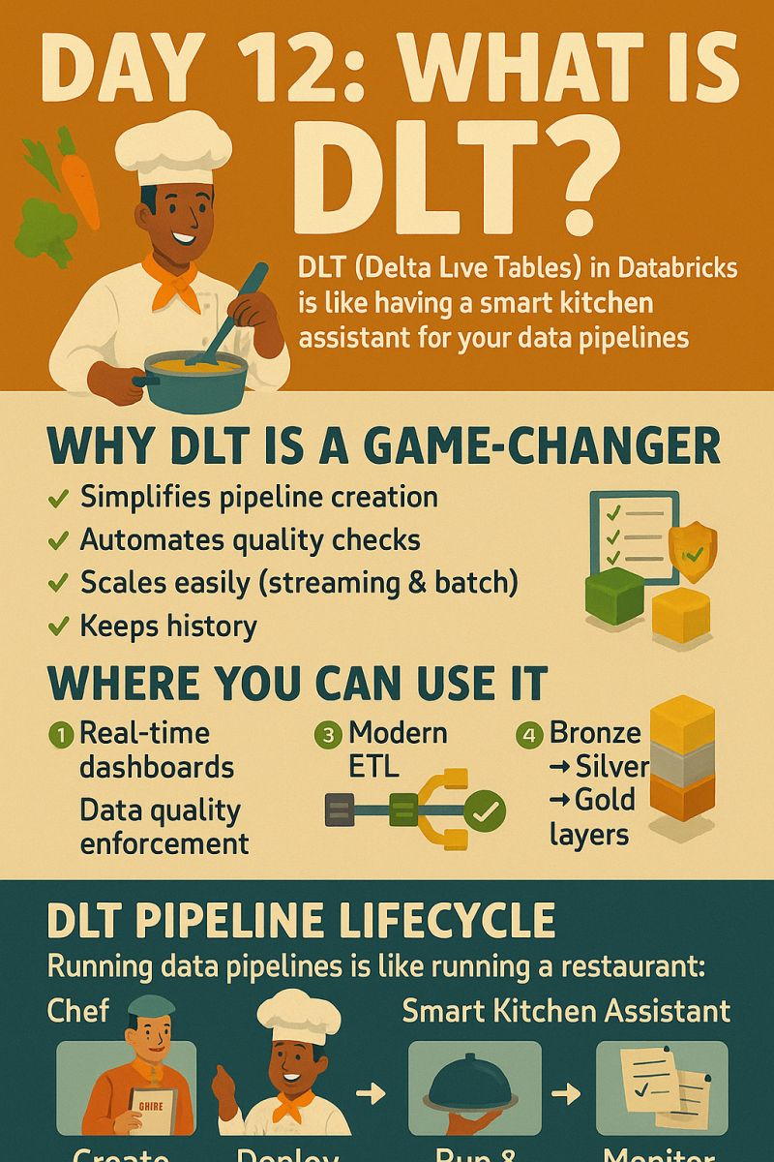  
  
💡 DLT (Delta Live Tables) in Databricks is like having your own smart kitchen assistant for data pipelines.  
  
You tell it what you want on the menu (data logic), and it takes care of how it’s cooked (execution, quality checks, scaling, recovery).  
  
Why DLT is a Game-Changer?  
💫Simplifies pipeline creation – No messy scheduling configs  
💫Automates quality checks – Enforces rules on your data  
💫Scales easily – Handles streaming + batch with the same setup  
💫Keeps history – Monitors runs and version changes for you  
  
🔍 Where You Can Use It  
1️⃣ Real-time dashboards – Fresh insights without manual refreshes  
2️⃣ Data quality enforcement – Catch bad data before it spreads  
3️⃣ Modern ETL – Replace fragile scripts with resilient pipelines  
4️⃣ Bronze → Silver → Gold layers – Manage transformation stages effortlessly  
  
⚙️ DLT Pipeline Lifecycle  
1. Create – Define sources, transformations, and sinks in SQL/Python  
2. Deploy – Publish once in Databricks  
3. Run & Maintain – DLT handles execution, scaling, and recovery  
4. Monitor – Track performance & data quality in the DLT UI  
  
🍽 Real-Life Analogy  
Running data pipelines is like running a restaurant:  
You (Chef) design the menu 🧾  
DLT (Smart Kitchen Assistant)  
Buys fresh ingredients 🥦  
Cleans and preps them 🔪  
Checks food safety ✅  
Serves dishes to customers 🍛  
Logs every order and issue 📒  
You focus on the menu (data logic), not washing dishes or fixing the fridge.